Gilbert Torossian John Trotta
Principal Assistant Principal

HIGHLIGHTS AND THE WEEK AHEAD

Polk Street Bulletin

Week of December 6, 2021
Dear Polk Street Parents,

It was so nice to have our Holiday Sale and Dino Dig back at Polk Street again. Just a reminder that we are currently collecting donations for our Toy Drive and 5th Grade “FUN”draiser to support those in need this holiday season.

All our best,

Gil Torossian and John Trotta

The Week Ahead:

Monday, December 6th Hour of Code Week

Tuesday, December 7th “Better, Not Bigger” Workshop (Grade 4)

Wednesday, December 8th Winter Concert Rehearsal

Thursday, December 9th REPORT CARDS AVAILABLE ON PARENT PORTAL

Winter Concert Rehearsal (see memo)

Friday, December 10th School Spirit Day (wear PSS attire or blue and white) Feel free to accessorize with holiday flair!

Winter Concert Rehearsal (see memo)

Upcoming Events:

December 13th Toy Drive Ends!

STEM Lab Week!

Grade 1 “Gingerbread Man” (Small gym)

Winter Concert Filming (AM)

December 14th

December 15th Faculty Meeting 8:15 am (Virtual)

“Better, Not Bigger” Workshop (Grade 4)

December 16th Guidance Counselor Visit (Grade 6)

Grade 6 Ice Cream Party (1:30 pm)

December 17th School Spirit Day (wear PSS attire or blue and white)

Accessorize with some holiday cheer!

Highlights:
Last Sunday was the first night of Hanukah and our student enjoyed learning about the Festival of Lights throughout the week. We wish all our families celebrating a wonderful 8th night of Hanukah tonight.
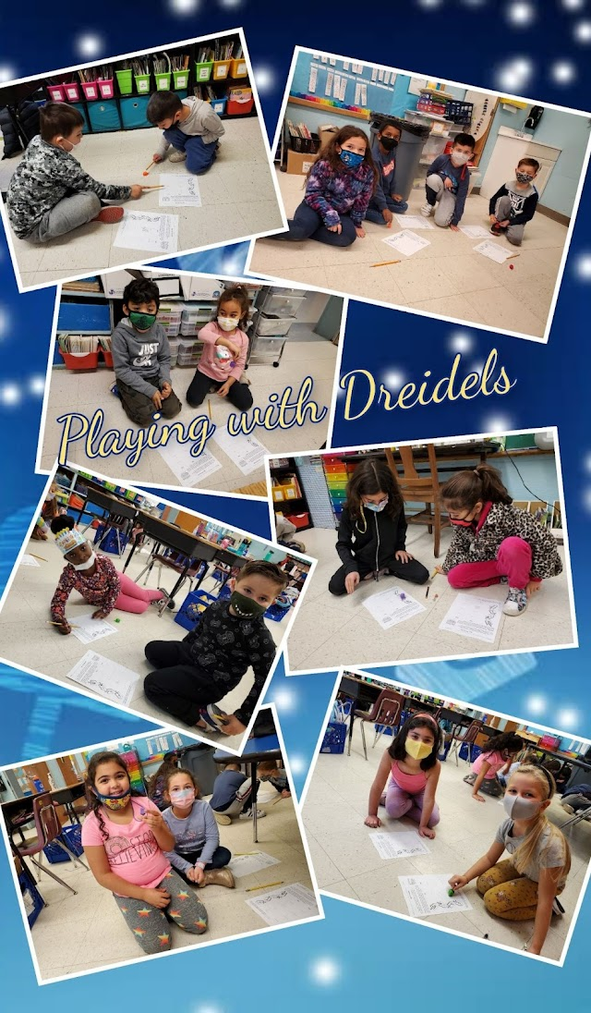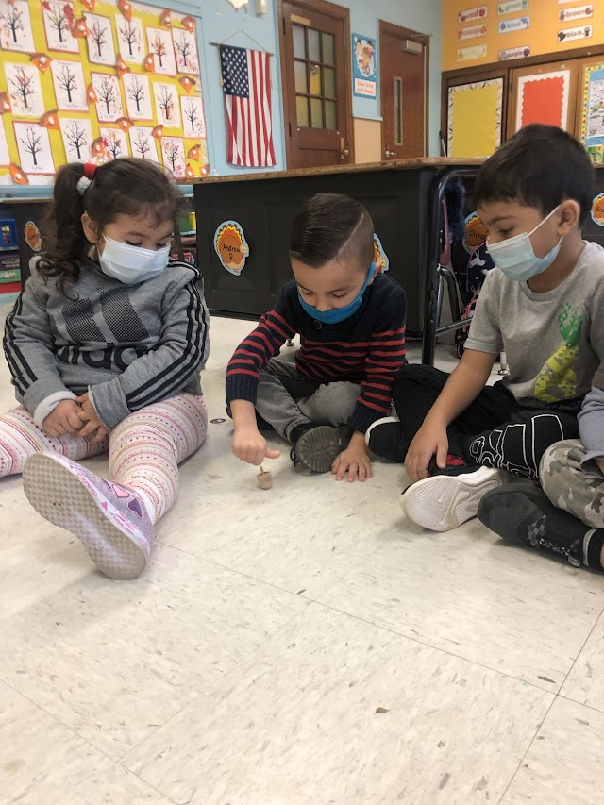
The PTA Holiday Sale was a huge hit with our community and a wonderful return to more normal and exciting times. Students enjoying shopping for the holidays set to music and lights and hosted by our fabulous PTA.
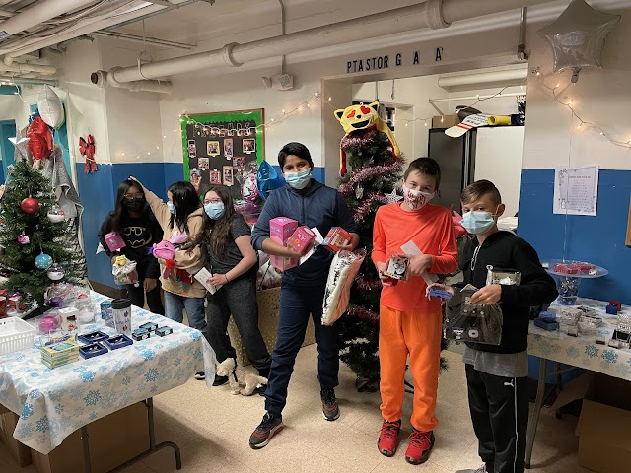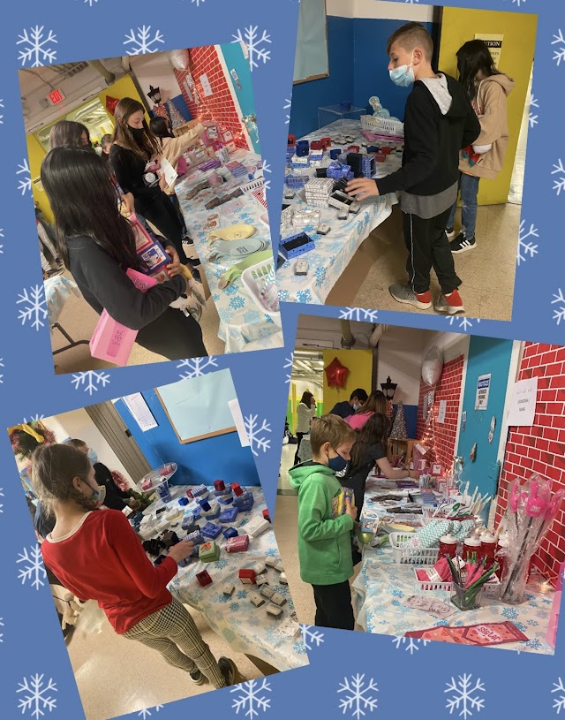

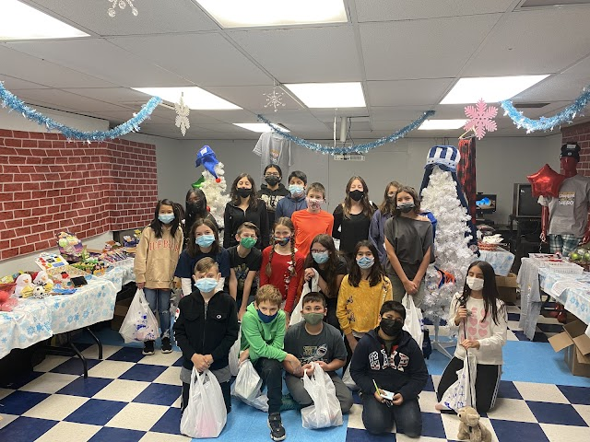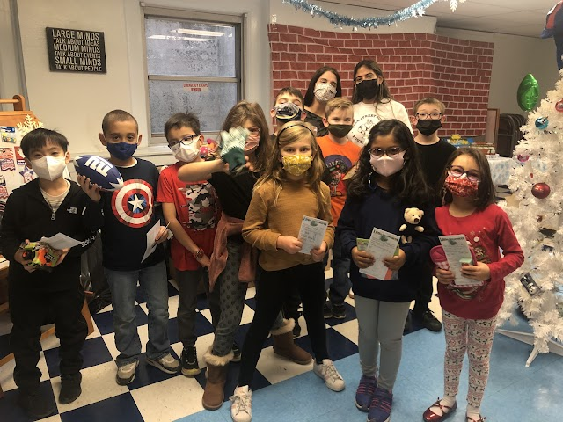
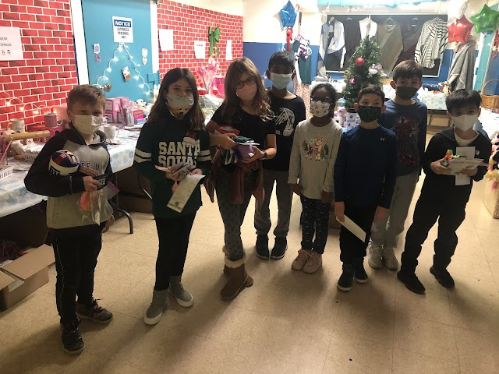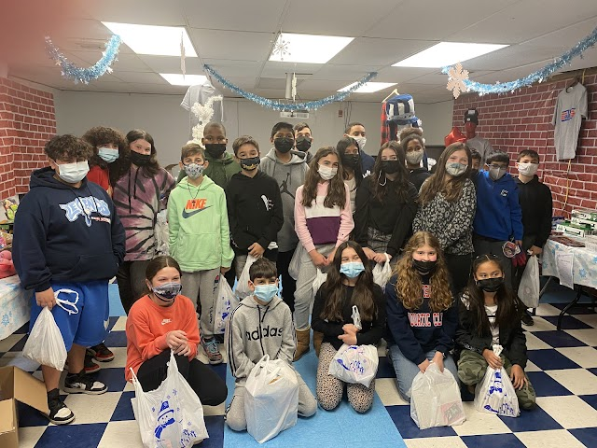
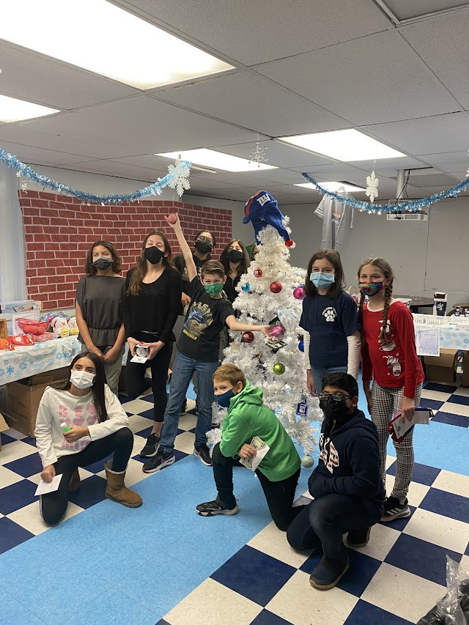

Grade 2 “Dino Dig” Kids had a wonderful time with the interactive assembly presented by Archeologist, Dr. Mike Stricka. The assembly was followed by an exciting dig for actual artifacts and fossils. Each second grader took home a mineral fossil as a parting gift.

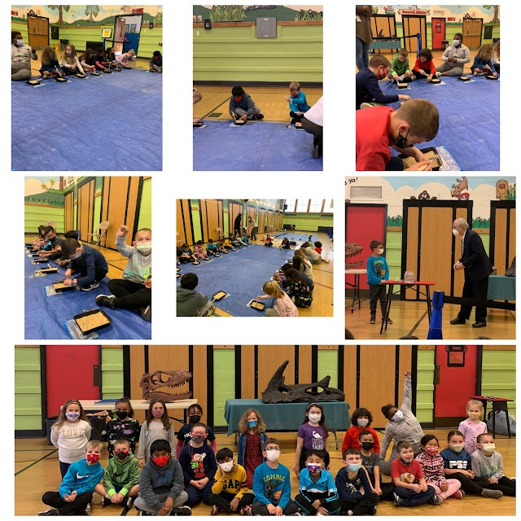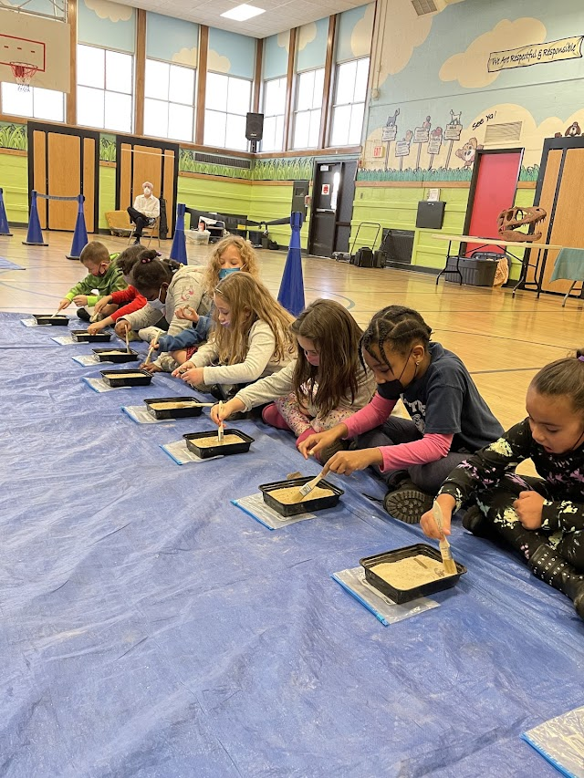

Students even dressed to represent their favorite dinosaurs.
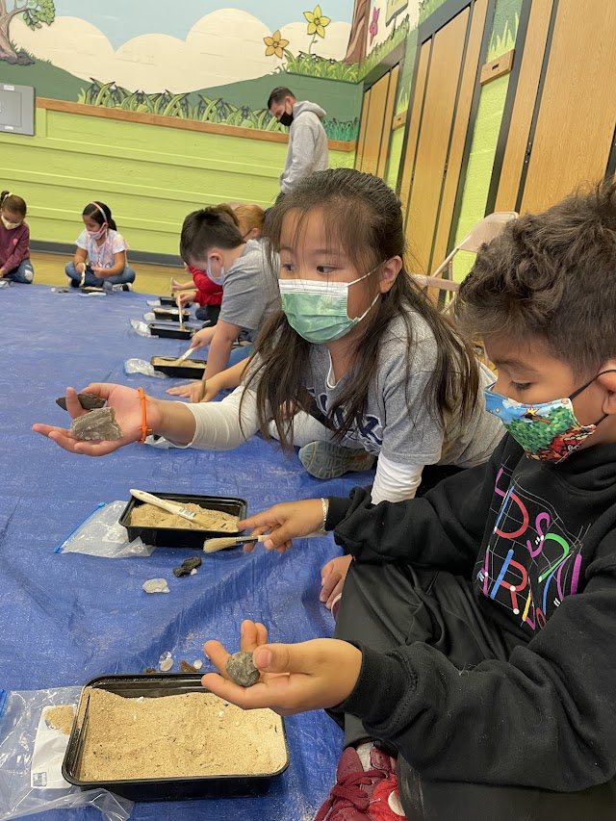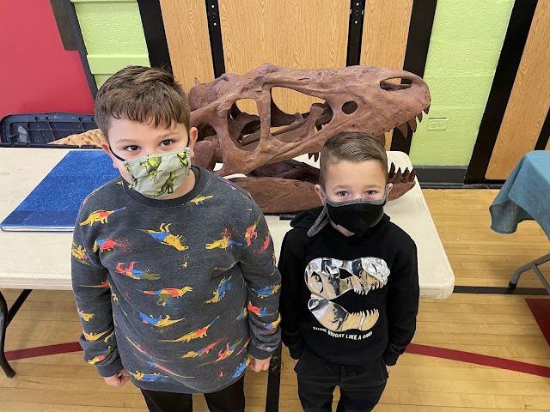
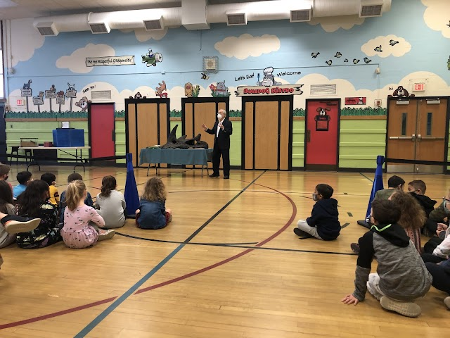
We thank our PTA for funding this awesome event!
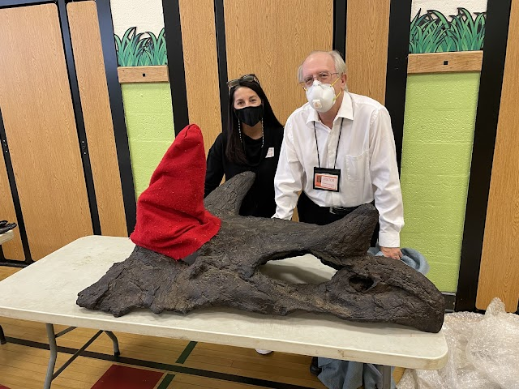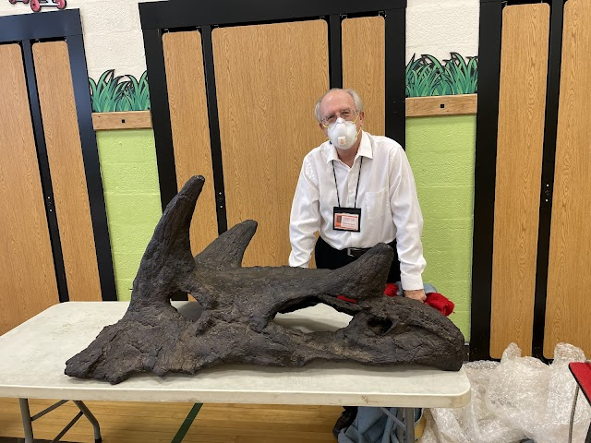

It’s great to be the King. Except for King George the III. Those 5th graders really knew their stuff as they interviewed the King about his taxation policy and reasons for the American Revolution!
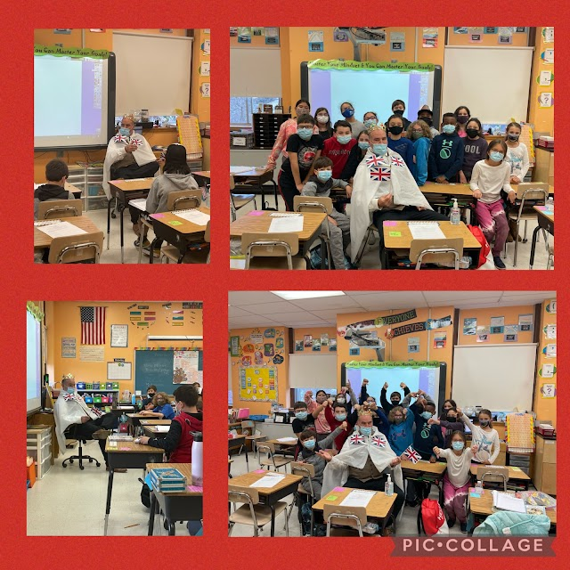
“Cooperation Quilts” were on display today to present Buddy Class completed quilts as classes worked cooperatively on this wonderful project. We thank our Staff Character Committee for putting this SEL lesson/activity challenge together.
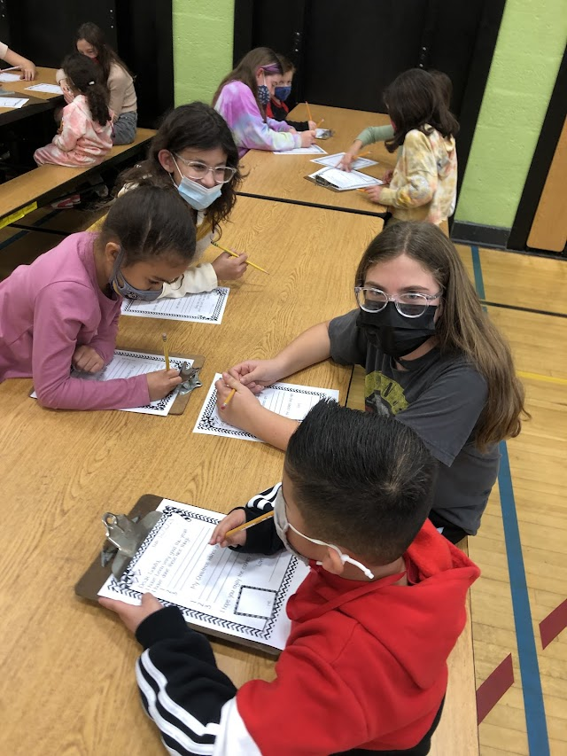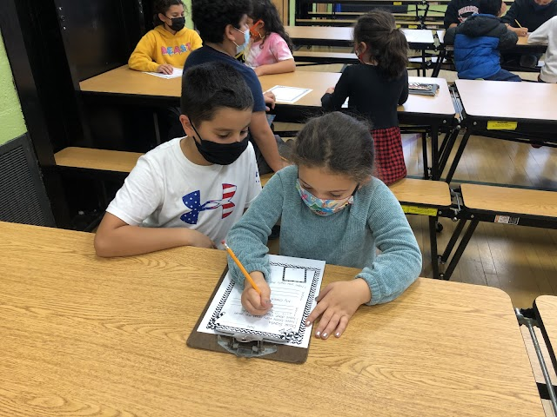
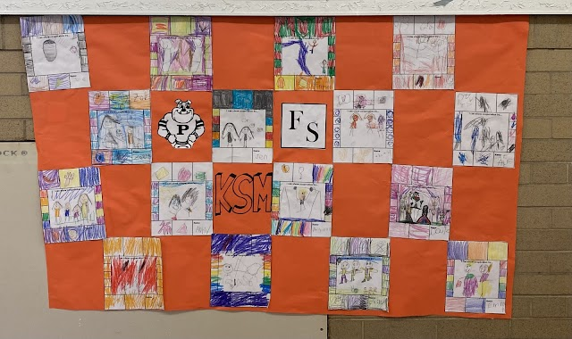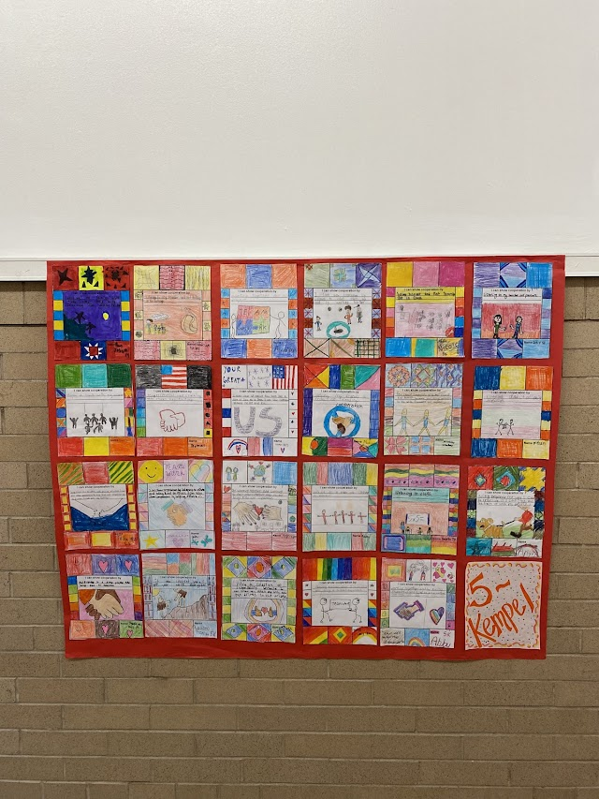

Congratulations to Maggie Tittler on her Engagement! 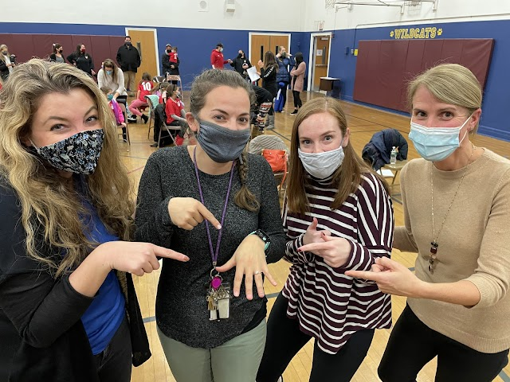

Here’s to a great week!

