Gilbert Torossian John Trotta
Principal Assistant Principal

HIGHLIGHTS AND THE WEEK AHEAD

Polk Street Bulletin

Week of November 22, 2021

Dear Polk Street Parents,

We started celebrating Anti-Bully week last Friday by wearing our Polk Street wear and Standing together against bullying. This weeks line-up is Monday we Team up Against Bullying by wearing our favorite sports jerseys, Tuesday is Trading Places Day as students dress like teachers and principals and we dress like students, and Wednesday is everyone’s favorite-Pajama Day as we Put Bullying to Bed. Have fun!

Please be reminded that our morning Stop and Drop Zone on Polk Avenue is not a place to park. If done right, it allows students to be dropped off quickly, efficiently and safely. If you would like to observe your child enter the school please park in a legal spot and walk your child onto school grounds. We thank you all for supporting a safe Stop and Drop.

The following is important information from our PTA
Class photos are now available for purchase online only. Envelopes "will not" be collected in school. All class pictures will be sent to the school. Cutoff to order class pictures is Friday 12/3. **Please Note** Sixth grade is not loaded yet.

Our first in person PTA meeting is set for Tuesday November 23rd at 7:30 pm, you need to be a paid PTA member to attend. Please click on the respective links below:
- PTA Meeting sign up
https://docs.google.com/forms/d/e/1FAIpQLSf2uERGIgVMDZblJ0i9alKS6BdRMsXHN68SQYuYPqviwAayww/viewform?usp=sf_link
- Membership sign up
https://psspta960.memberhub.com/store

There is still time to sign up and volunteer for our Holiday Sale please click on the following link to register: https://www.signupgenius.com/go/60b044baaa72fabfc1-holiday4

Wishing us all a wonderful week,

Gil Torossian and John Trotta

The Week Ahead:

Monday, November 22nd Anti-Bullying Week “TEAM Up Against Bullying”

(wear your favorite sports team jersey)

Grade 1 “Corn Bread Lesson” (9:00 am - Small Gym)

Tuesday, November 23rd 1st Marking Period Ends!

AR Cutoff Date!

“Trading Places” The true definition of empathy.

(Students: Dress like Teachers or administrators) (Teachers: Dress like Students)
Bus Drill

PTA Meeting 7:30 pm in large gym

Wednesday, November 24th “Put Bullying to Bed” (Wear pajamas and be EXTRA kind!)

Early Dismissal (2:45 pm)

Thursday, November 25th THANKSGIVING RECESS – SCHOOL CLOSED

Friday, November 26th THANKSGIVING RECESS – SCHOOL CLOSED

Upcoming Events:

November 29th Toy Drive Begins!

November 30th PTA Holiday Sale

December 1st 5th Grade FUNdraiser Starts!

PTA Holiday Sale

BOE Meeting (8:00 pm) (WSS)

December 2nd PTA Holiday Sale

December 3rd School Spirit Day (wear PSS attire or blue and white)

Grade 2 “Dino Dig” (see schedule)

“Cooperation Quilts” on Display!

Highlights:

Kindergarteners and 1st Graders enjoyed their visit with Nature Nick and his menagerie of animals ranging from alligators to a Siberian Bunny named Mr. Sprinkles. We thank our PTA Cultural Arts team for funding this awesome assembly.

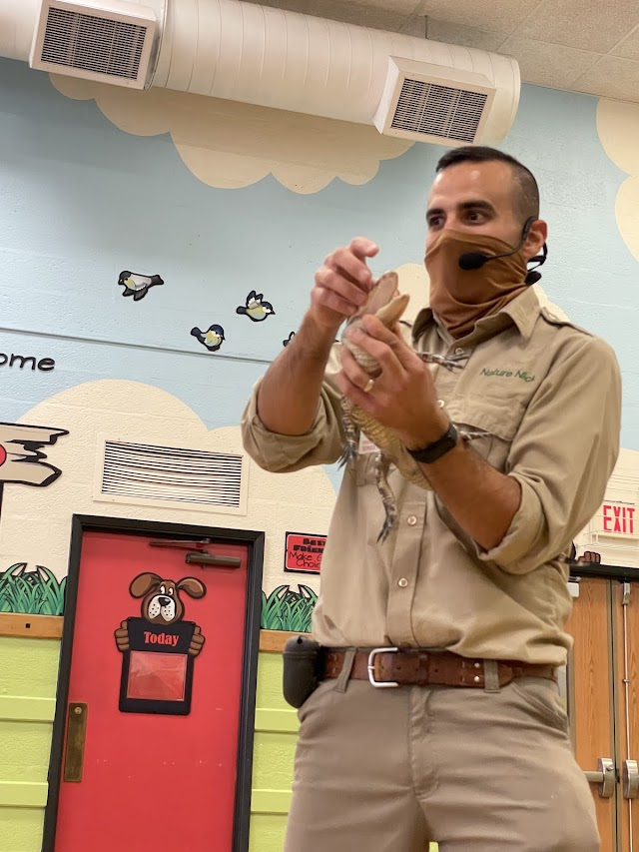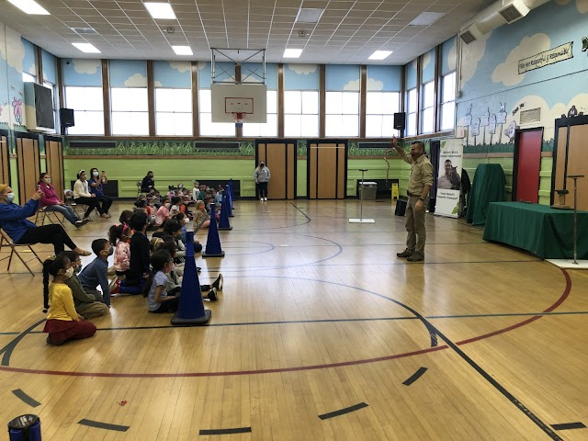

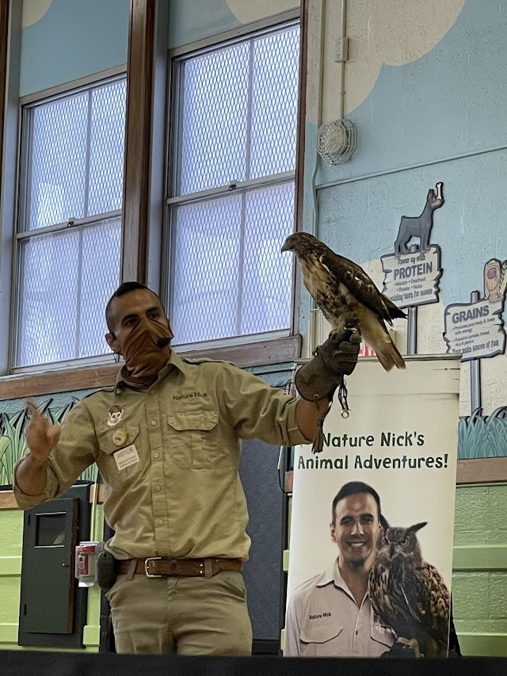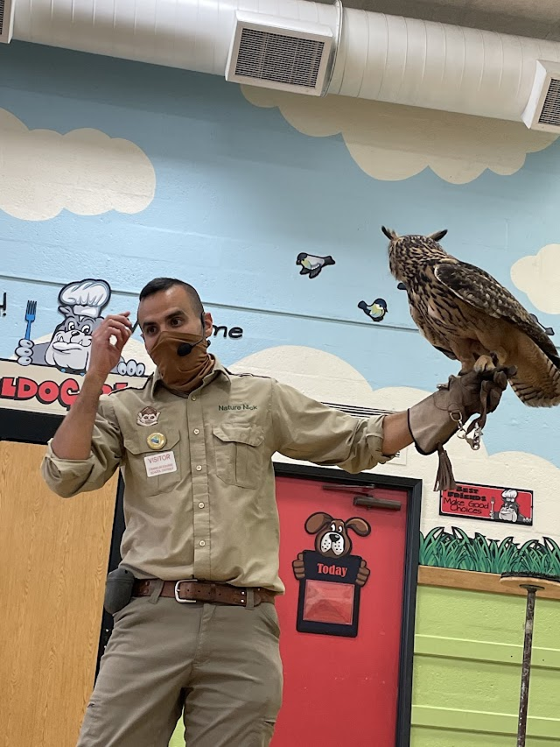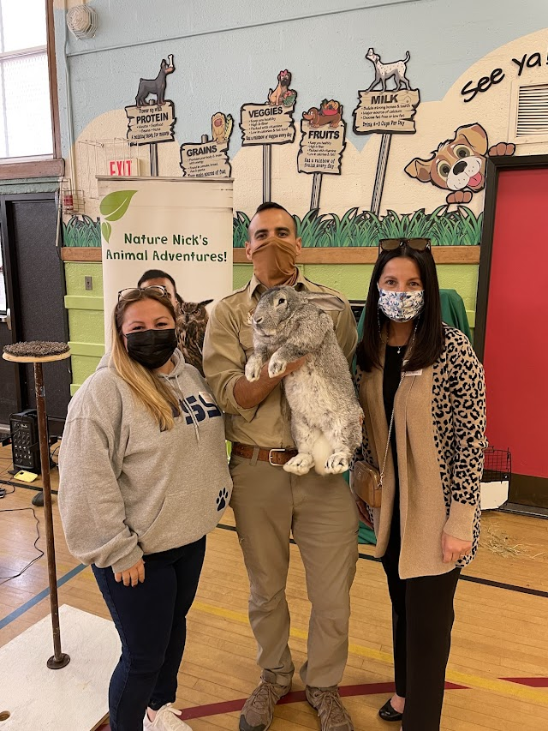
Kindergarteners and 1st graders are doing all they can to camouflage Tom turkey, as we get closer to Thanksgiving. They and their parents get so very creative!

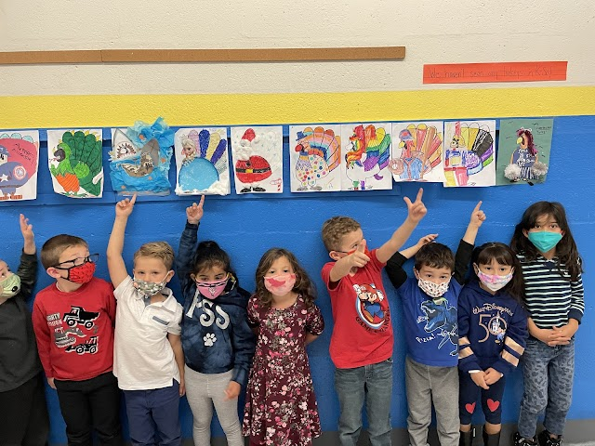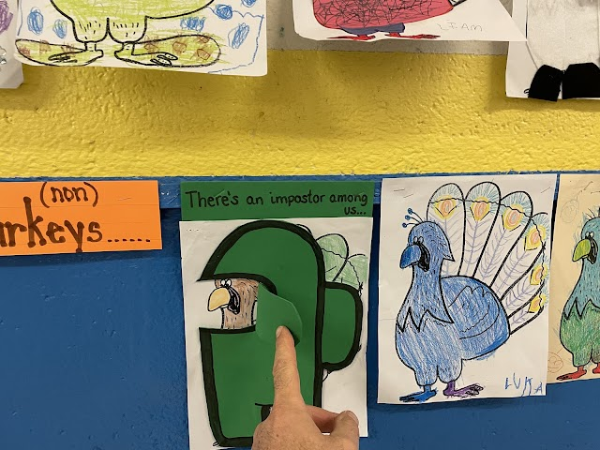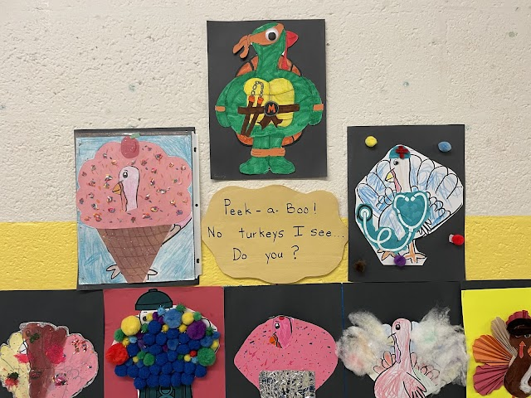

6P and 6R had a great time at the Sands Point Preserve investigating forest and beach biomes and taking a cool nature walk.

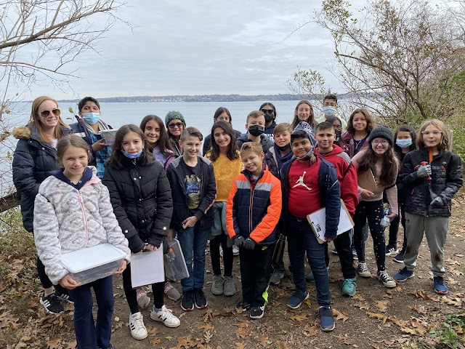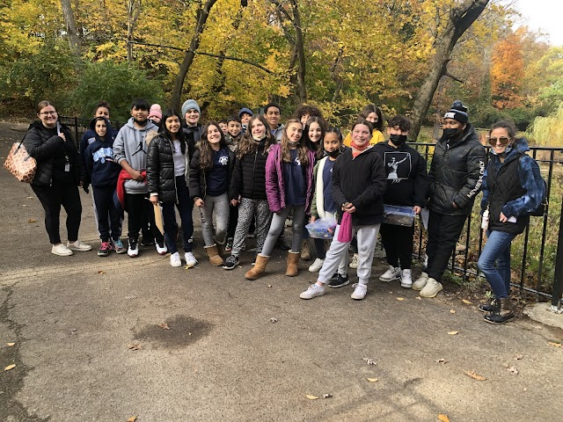

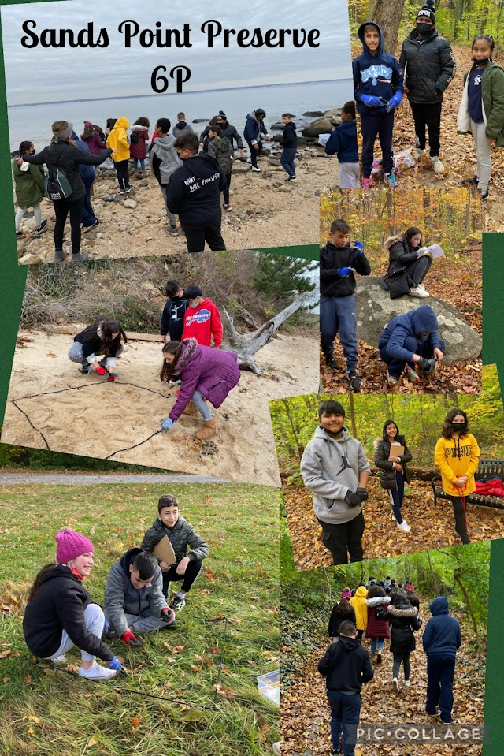

Friday was Polk Street Stands Together Against Bullying Day and Polk Street wear was out in full effect. We thank our PTA for the new merch and love seeing our students working Cooperatively on their beautiful quilts.

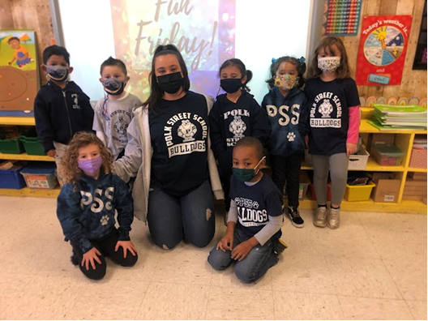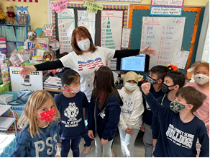

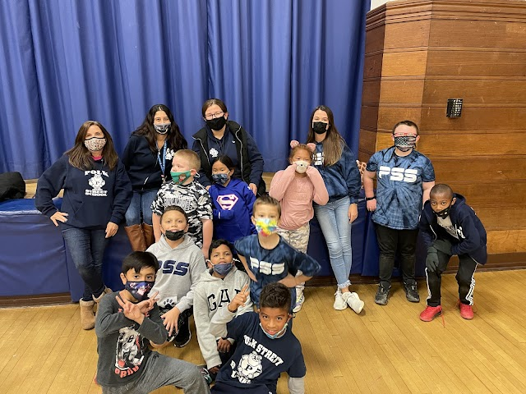

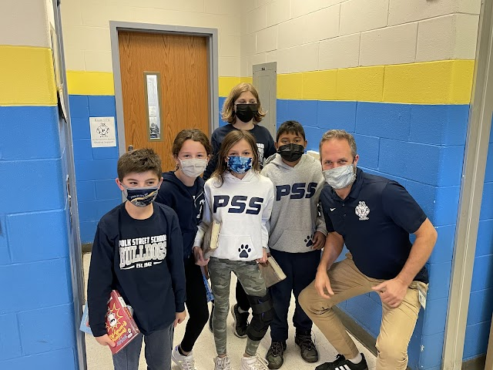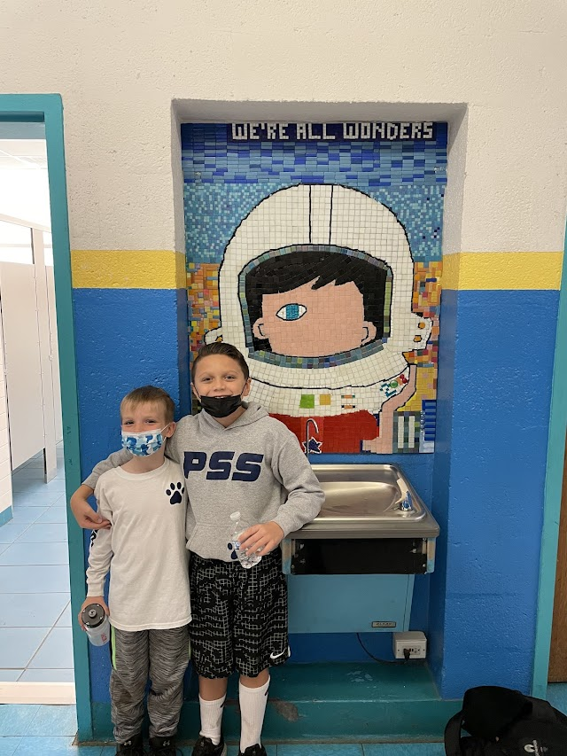

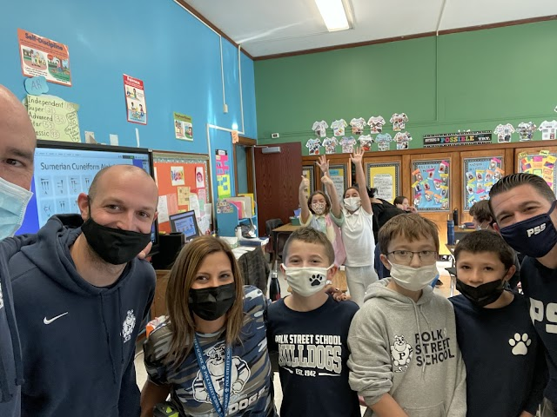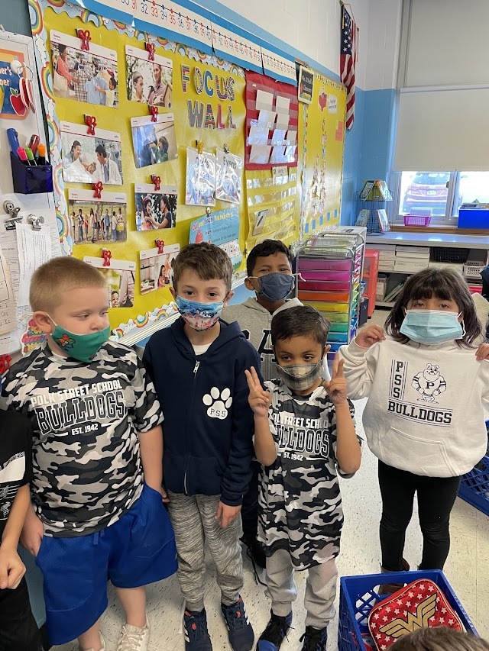
We thank our 2nd Grade students for their wonderful success with this year’s Quarter Drive. Polk
Street School Community collected $1720 dollars to support families in need this this holiday season. We also thank restaurant Chat Noir of Rockville Center for their donation of dinner for 9 this Thanksgiving Season.


